Proposal

Grainger
Renewals Process

Version 1.0
October 23, 2024

Contents
1 Executive Summary 3
1.1 Introduction 3
1.2 The Business Opportunity 3
1.3 The Project 3
1.4 The Business Benefit 3
1.5 References 4
2 Proposed Solution 5
2.1 Proof of Concept Screens 6
2.2 Solution Context 8
2.3 Recommended Project Phasing 9
2.4 High-Level Design 2
2.5 Salesforce Licensing 9
2.6 Support 9
2.7 Training 10
2.8 Prerequisites 10
2.9 Exclusions and Limitations 10
2.10 Assumptions 11
3 Detailed Costs 12
3.1 Extension of Service Period 13
3.2 Dependencies 13
4 Delivery Approach 15
4.1 UAT 16
4.2 Project Management 16
4.3 Availability 16
5 Acceptance 17

Executive Summary

Introduction
Grainger plc have engaged with Open Box to redesign the existing Renewals Journey in their Salesforce org.
​​The renewals process is currently shoehorned into the Salesforce leasing journey which is designed primarily for new leases. Many key inputs for this process are held out of system (including price book rent in spreadsheets) or in other systems (such as arrears balances in Qube), which require considerable manual effort to key into offline spreadsheets that are circulated between teams.
Limitations with the existing portal in which tenants review offers, result in tenants being regularly unable to access the portal and prevent offers for multiple units from being sent at the same time.
Additionally, the likely introduction of the Renters’ Rights Bill in 2025 must be considered as this will have a notable impact on the renewal process for the majority of Grainger’s tenants.

The Business Opportunity
Grainger plc have identified that redesigning the renewals process would significantly reduce manual data entry, the cost of late renewals and void days.

The Project
Open Box will enhance the existing Renewals Journey in Salesforce by replacing the existing tenant portal for renewal offers as well as the offline renewal spreadsheets thereby delivering functionality that will remain relevant once the Renters’ Rights Bill is enacted.
The solution will minimize manual data entry, eliminate the need to cross-check information between Salesforce and Qube, and maintain a full history of offers and counteroffers.

The Business Benefit
The proposed solutions will help to:
- Improve speed & efficiency of the process, allowing business to scale operations without necessitating a linear increase in headcount.
- Obtain notice to quit from tenants earlier in the process, minimizing void days and void costs.
- Obtain renewal preferences from tenants upfront, allowing for renewal offers to be tailored.
- Build the foundation for a single view of tenancy within Salesforce.
- Improve the tenant experience with a robust online platform.
- Highlight renewals approaching deadlines to avoid delayed rent increases.
- Reduce offline communications between teams and minimise back-and-forth between tenants and renewals negotiators.
- Provide a single source of truth for renewal data.
- Reduce errors.

References
- Renewals – As Is Process Diagram v1.0_ 2024 08 29.pdf
- Renewals – Proposed Future State Process Diagram v1.0.pdf

Proposed Solution
Open Box proposes to enhance the existing Renewals Journey in Salesforce.
Release 1 will address the following objectives which are further detailed in the feature backlog:
- Manage Denied List – Provide ability to deny a renewal mid-term, blacklist tenants and monitor tenancies on the denied list.
- See Current Tenancy Arrears – Import the current tenancy arrears balance from the data warehouse and view as part of tenancy and renewal information.
- Upload Price Book Rent & ERVs into Salesforce – Enable support users to upload spreadsheets containing Price Book Rent, Grainger Trust prices, ERVs and updated license prices into Salesforce as and when updated.
- Automatically Create Renewal Opportunities – based on up-to-date tenancy data; replacing the lease end diaries in Qube.
- Tenant Provides Intention to Renew – Prompt tenants to provide an early indication of whether or they intend to renew, request changes to tenancy terms, or raise issues that may affect renewal and notify the relevant users.
- PM Approve Renewals – Enable Property Mangers & Resident Services Mangers to review upcoming renewals, indicate whether to renew, deny or defer the renewal, and make comments.
- AM Update Offer & Minimum Price – Enable Asset Managers to review upcoming renewals, ERVs, price book rent and set an offer and minimum price.
- See Projected Growth on Rent – Provide a dashboard for Asset Managers to see growth on rent by asset and region, based on projected renewal prices.
- View Unit Condition & Block Pricing Factors – Enable PMs/RSMs to maintain unit condition and block-level pricing factors in Salesforce which Asset Managers can see when reviewing renewal pricing.
- Renewals Team Validate Renewal before Offering – Enable Renewals Negotiators to access a list of renewals ready for their review with prepopulated offer details, and see outstanding information/blockers at a glance. Additionally provide a list of all renewal opportunities in progress that highlight any at risk of timely renewal.
- Tenants Respond to Offers – Email offer details to the tenant, enabling them to respond online by giving notice to quit, accept the offer or make a counteroffer. Tenants may review offers for multiple units at the same time.
- Track Tenant Renewal Requests & Blockers – Notify PMs/RSMs where a tenant makes a request or complaint during the renewal process, enabling the Renewals Negotiator to see when it is resolved & the outcome.
- Manage Counteroffers & AM Approval – Notify the Renewals Negotiator of counteroffers and require Asset Management approval where necessary, maintaining a full history of offers and counteroffers.
- Initiate an End of Tenancy – where a tenant provides notice to quit or where there is an internal move confirmed during the renewal process.
- Manage Deferred or Deny Renewals – Automatically flag tenancies and tenants as denied, save the date on which to create the next renewal opportunity, and/or close the renewal opportunity as applicable.
- Align Salesforce & Qube Tenancy Data Model – Create a master tenancy in Salesforce that maps to the Qube tenancy and provides a single view of tenants/related parties, opportunity and tenancy version history.

Proof of Concept Screens
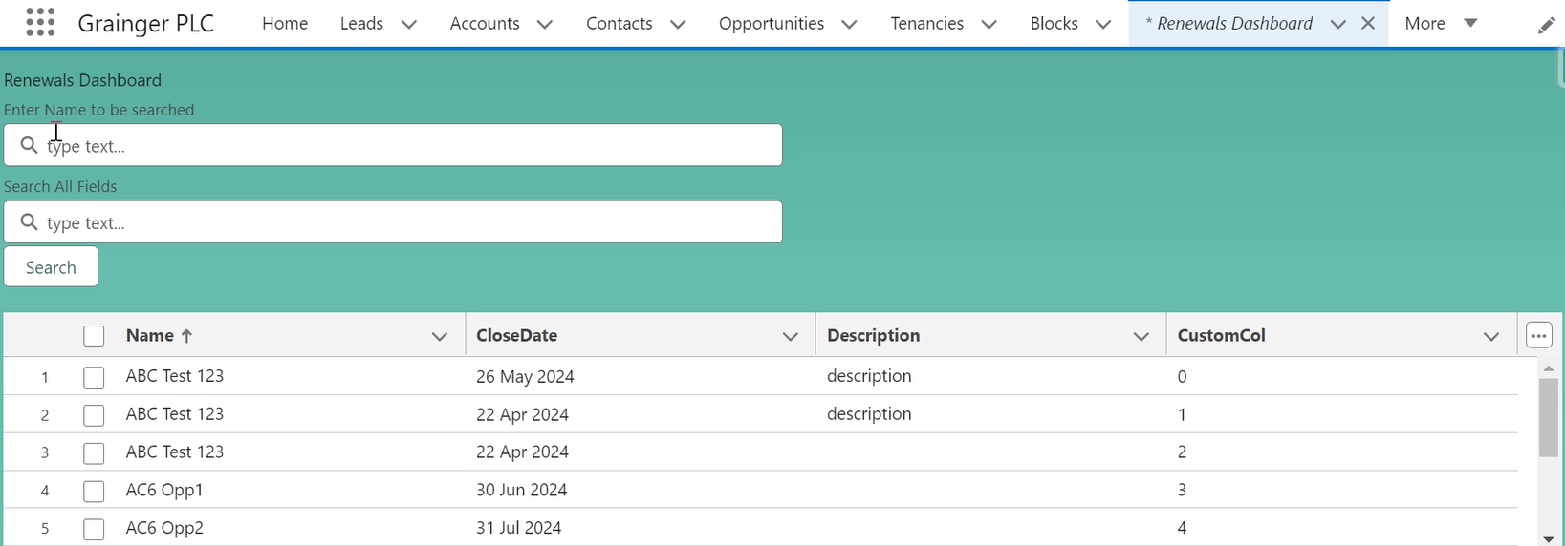
Figure 1: POC of a List View to Replace the Renewals Spreadsheet
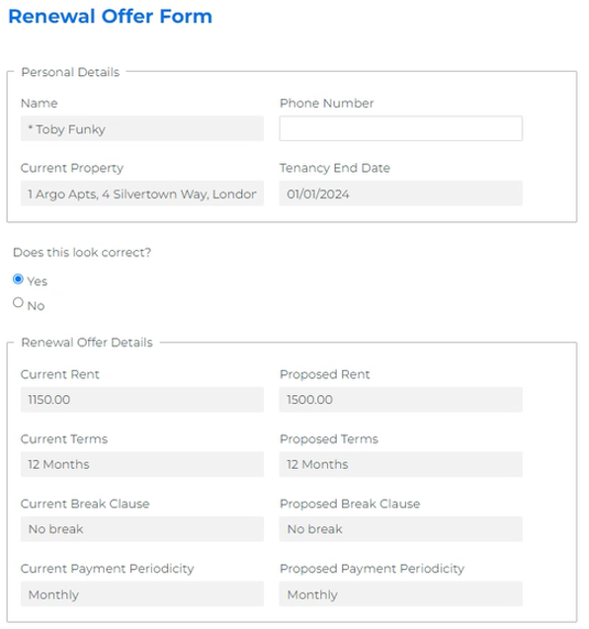
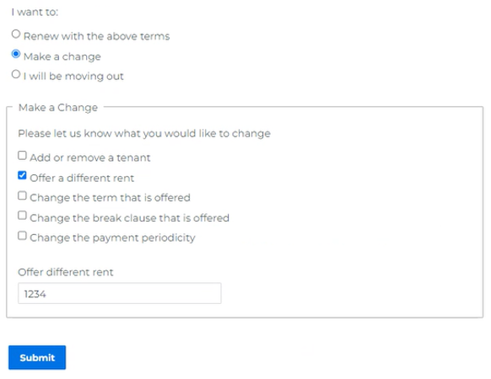
Figure 2: Form Assembly Proof of Concept - Tenant Reviews & Responds to Offer

Solution Context
The following provides an overview of the solution’s interfaces and users:
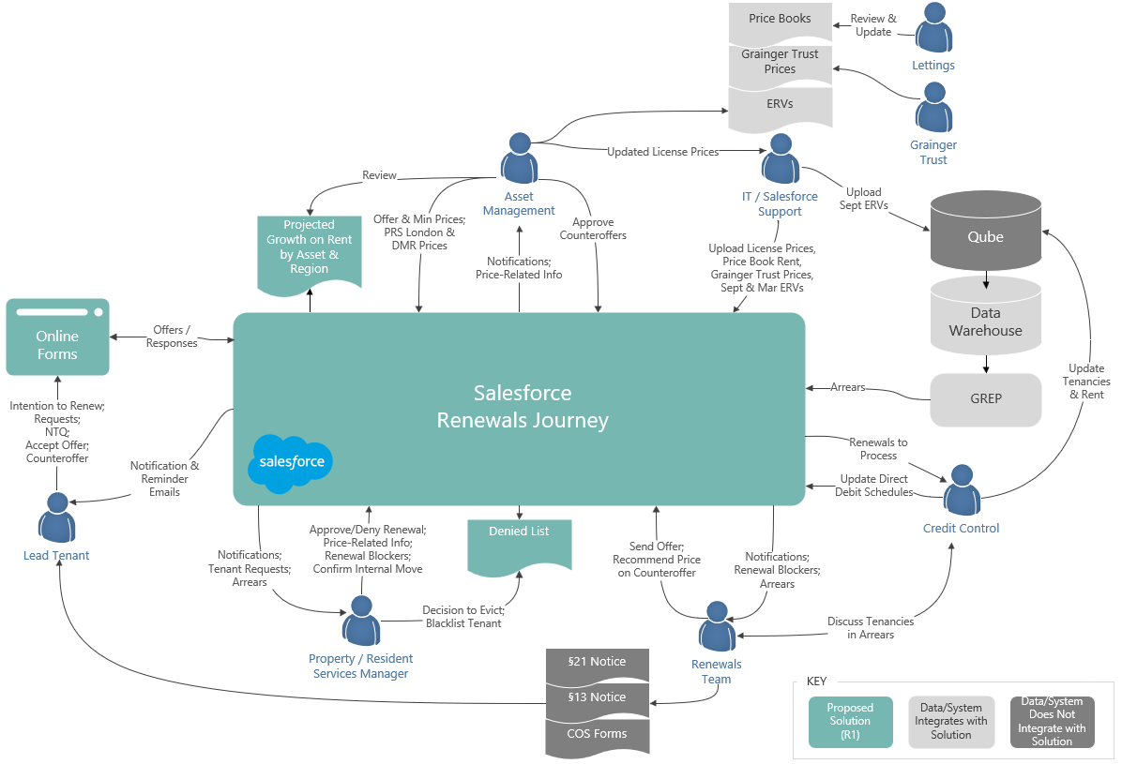

Figure 3: Proposed Solution Context Diagram (Release 1)
- Data Warehouse – Any current tenancy arrears balance will be imported from the Data Warehouse (via the GREP integration layer) and updated once daily.
- Pricing Spreadsheets – Support users will update Salesforce price books (including ERV price books) by uploading spreadsheets provided by various departments.
- Tenants – The lead tenant will receive system-generated notification & reminder emails with a link to provide responses via online forms (implemented using Form Assembly).
- Property Managers / Resident Services Managers – Will receive notification of renewals to renew and tenant requests, and provide their renewal decision, any feedback on the tenant, notes on unit condition, and updates on tenant requests/renewal blockers directly in Salesforce.
  - PMs will track denied tenancies and evictions on the Denied List that has been moved out of Qube.
- Asset Managers -
- Renewals Team -
- Credit Control – Interaction with the renewal opportunities will remain unchanged; Qube and direct debit schedules will continue to be updated manually.

Recommended Project Phasing
The recommended scope of release 1 therefore overhauls the initial phases of the renewals process, up to the point that the tenant accepts the offer. Thereafter, the existing renewal process and functionality will remain in place.
The second and any subsequent releases would build upon these enhancements, providing functionality to support the Renters’ Rights Bill.

The following illustrates the proposed changes to the renewal opportunity stages in release 1:

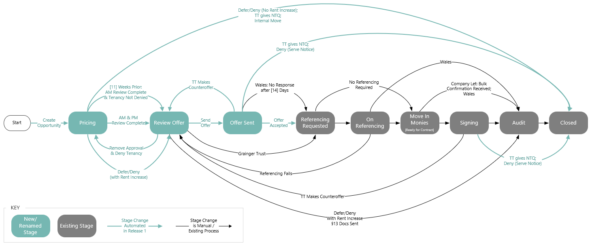
Figure 4: Proposed Renewal Opportunity Stages – Release 1

The following depicts the interaction between existing processes and new functionality to complete the end-to-end renewal:
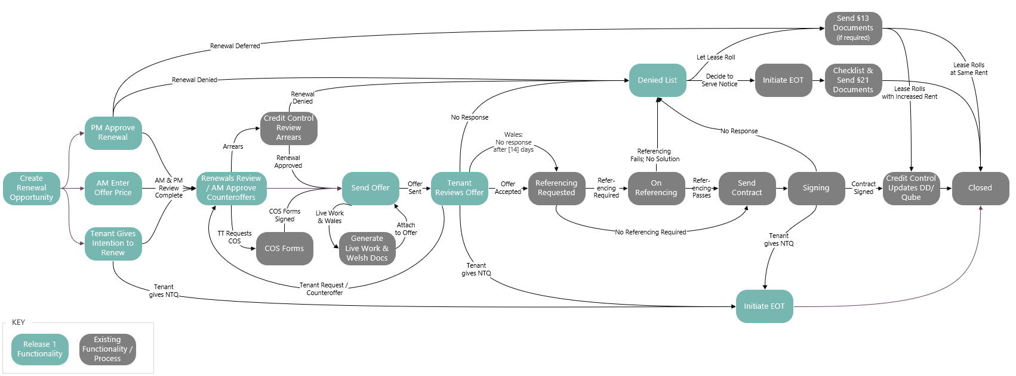

Figure 5: Proposed Relationship between New & Existing Functionality for Release 1

Additional functionality can be added in subsequent releases to support the future process that will be required post-Renters’ Rights Bill:
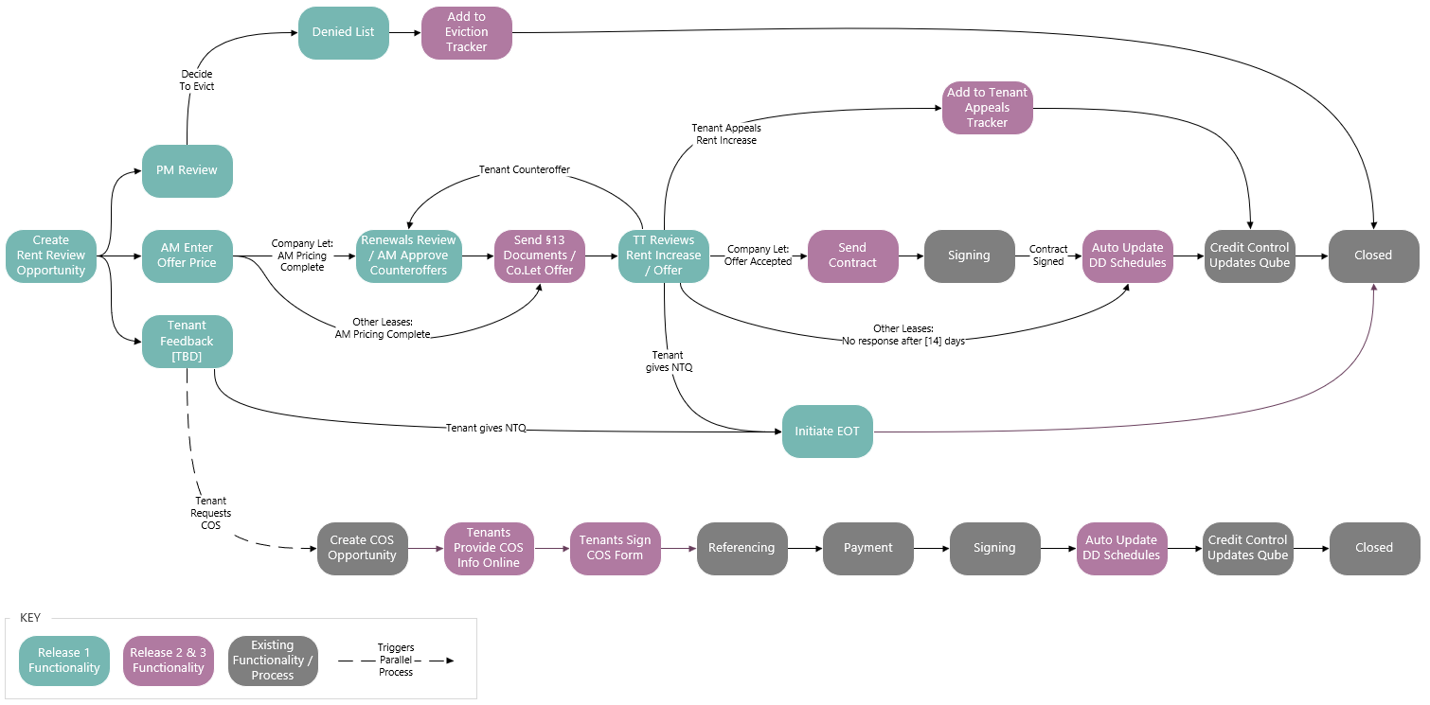

Figure 6: Envisaged Future Functionality to be added Post Renters’ Rights Bill

Additional functionality that is not included in the initial project scope as outlined above, may be addressed in future project releases.
Recommended project phasing is as follows:
- Release 2 – To go live with the Renter’s Rights Bill:
  - Send tenants a notification of rent increase (section 13 letter) instead of offers (for applicable agreement types).
  - Customise the renewals journey, including generating alternate documentation and alternate email templates, for:
    - Wales
    - Company Lets
    - Live/Work Units
    - DMR & Grainger Trust Units
  - Give PMs visibility into upcoming rent increases.
  - Eviction Tracker
  - Tenant Appeals Tracker
  - Display additional information on the renewal opportunity to assist Credit Control (any Direct Debit Authorizations that are not yet 'In Force' & calculated blended payment charge where rent increases mid-month).
  - Ensure the Audit step is not skipped in the renewals process.
  - Differentiate Mid-Term Change of Sharer from renewal opportunities (for reporting).
  - Provide a new dashboard for Asset Management that displays comparable rent & current performance by estate & unit type.
- Release 3
  - Omni-channel communications & WhatsApp integration (Renewals Pilot)
  - Import passing rent from Qube
  - Automatically update direct debit payment schedules in Salesforce on Renewal and mid-term change of sharer.
  - Tenants complete and sign change of sharer forms online.
  - Allow for bulk negotiation for Company Lets.
- Additional functionality that may be addressed as separate projects:
  - Automatically update tenancy information & rent charges in Qube on renewal.
  - Manage & calculate Price Book Rent within Salesforce.
  - Visibility into all tenant incidents, complaints, grumbles & satisfaction survey feedback within Salesforce.

High-Level Design
This document provides a high level design for the proposed renewals journey enhancements to be implemented on Grainger’s Salesforce org.
The design is intended to establish the key architectural decisions that will underpin the solution and ensure that it adheres to the 3 key principles of the Salesforce Well-Architected Framework:
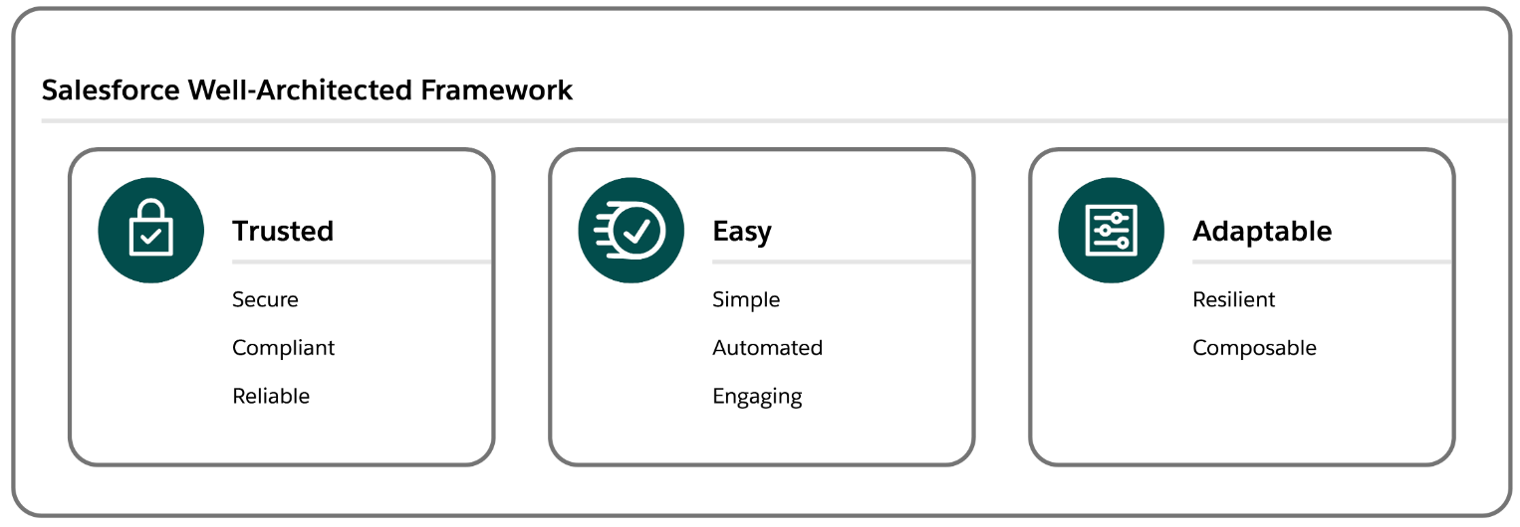
- Trusted solutions protect stakeholders
- Easy solutions deliver value fast
- Adaptable solutions evolve with the business.
This design does not cover the lower level detail (e.g. fields, profiles, automations, validation rules) – these will be designed and documented at user story level during the agile implementation phase.

Salesforce Strategy

Org Strategy
At this point in time there are no requirements (e.g. data residency, large data volumes, autonomous business units etc.) that would require a multi-org strategy, thus the Void Management process will follow a single org strategy and will be implemented on the existing Grainger PLC Salesforce org. Among other benefits, a single org provides the best solution to easily deliver unified processes, a single view of the customer and lower total cost of ownership.

Document/File Management
It is understood that the current document management system (DocuShare) is being retired in June 2024, currently with no replacement having been identified. It is recommended that the Void Management Process make use of Salesforce Files to manage the various documents that are collected and collaborated on. Salesforce Files will allow documents to be attached in context to the records they relate to – e.g. photos of damage to paint work may be attached to a task being created to book maintenance work. This allows easy collaboration and sharing across the multiple teams that are involved in the Void Management Process.

Archival Strategy
Salesforce file and data storage capacity is limited and is determined by a base allocation at org level plus a per-user allocation. Any overage will require the purchase of additional storage from Salesforce. Additionally for data (i.e. records rather than files), a high number of records of any one object can result in large data volume (LDV) performance limitations (report timeouts, slow page loads etc.). Thus it is desirable to operate within the allocated capacity if possible and implement an archival strategy to move data and files off-platform at a point in time where users no longer need to interact with them.
In order to calculate data and file volumes, the following assumptions have been used:
- Number of units: 13 000 in year 1, scaling to ±30 000 in year 5
- Number of voids per year: 1 void per unit
- Number of tasks per void: 40
- Number of files per void: 10
- Average file size: 2MB
Based on these assumptions, the table below shows predicted data and file storage requirements.

File Archival
Grainger PLC’s Salesforce org currently has a 503GB file storage limit, of which 66GB is already used. Based on the projected volumes above, this limit would be exceeded in the second year of operation. While not required for the go-live of the Void Management solution, it is suggested that an archival policy be considered so that files can be automatically moved (e.g. via GREP) from Salesforce to a more cost effective storage solution (e.g. SharePoint). Files should be archived at a point in time where users no longer need to interact with them directly from Salesforce, for example 6 months after a void has been completed. File-specific policies may also be implemented, for example the inventory pdf may be retained on the Salesforce platform for longer than photos of painting works.

Record Archival
Grainger PLC’s Salesforce org currently has a 14.8GB data storage limit, of which 7.5GB is already used. Based on the projected volumes above, the data storage limit is likely to be exceeded within the next 5 years. While not required for the go-live of the Void Management solution, it is suggested that an archival policy be considered so that records can be automatically moved (e.g. via GREP) from Salesforce to a more cost effective storage solution (e.g. Azure SQL). Records should be archived (or deleted) at a point in time where users no longer need to interact with them directly from Salesforce, for example 6 months after a void has been completed. Object-specific policies may also be implemented, for example Void records may be retained on the Salesforce platform for longer than the tasks that relate to the void.

Archival Strategy Recommendation
There is no need for the immediate implementation of any archival strategy. Given that the above calculations are based on assumptions, it is recommended that volumes be monitored during the course of operations. Based on actual record volumes a suitable archive strategy and timelines can be planned.

Mobile Strategy
It is recommended that the Salesforce Mobile App be used to provide mobile access where required. There are no offline, branding or native device capability requirements that would necessitate any custom mobile app development.

Reporting Strategy
Operational reporting needs can be met via Salesforce reports. Should deeper analytical capabilities be required in the future, these can be met via a BI solution such as Power BI coupled with an Azure SQL data warehouse.

Third-Party Applications / Add Ons

Form Assembly
Add details here >>>>>>>>
Security Considerations.

Data Model

Entity Relationship Diagram
The following key changes are proposed to the high-level data model in order to support the enhanced renewals journey:
- Price Books
  - New price books would be added to the existing, standard Salesforce objects to save the following in Salesforce:
    - Price Book Rent – A separate price book would be created for each month (e.g. Price Book Rent for January 2025 new lets / renewals).
      - These price books would also include prices for non-live units and Grainger Trust units.
      - Each renewal opportunity would be linked to the price book for the renewal month.
    - ERVs - A separate price book would be created for each month for which ERV values are received (e.g. ERV as at March 2025).
      - The existing ERV fields on the Unit object, which do not allow for a history of ERVs to be saved over time, will be removed/hidden.
  - The existing ‘Standard Price Book’ would remain unchanged and would continue to be used by the new lease process.
- Master Tenancy
  - Master tenancy records will be added to Salesforce within the existing tenancy [Contract] object with a new record type.
  - The existing tenancy records (which represent a contract agreement within the overall tenancy) will be child records to the parent/master tenancy.
  - Each master tenancy in Salesforce will be mapped to a Qube tenancy to facilitate future integration.
  - The tenancy denied status, decision to evict, current arrears balance and next rent review date would be added as new data attributes and saved on the master tenancy.
- Tenancy Contact Role
  - The existing ContractContactRole object, which is not currently populated, will be used be save a full history of all tenants and related parties associated to a master tenancy over time.
  - This data would correspond to the ‘Child Tenant’ data in Qube, and would include a start date, end date, role and status for each related party.
- Offers
  - The existing

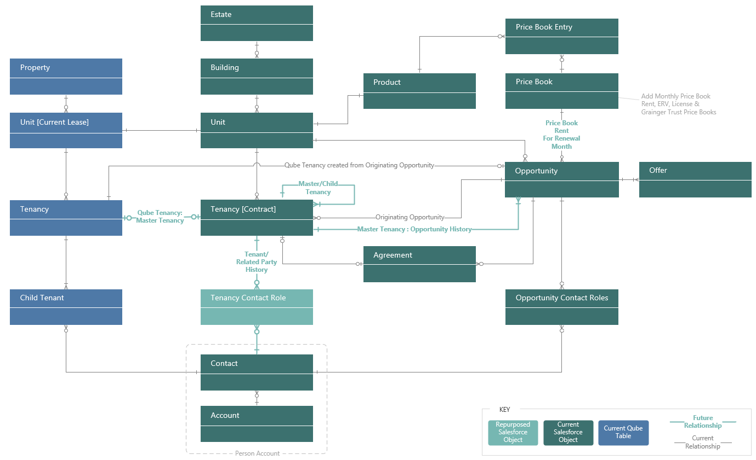

Figure 7: Entity Relationship Diagram

Data Sharing & Security
The Grainger PLC Salesforce org currently has a public read/write org wide default (OWD) for all key objects (Account, Opportunity, Tenancy) and allows all users to view all records. Where no security requirements exist to restrict visibility, this solution provides full visibility to all users and facilitates easy collaboration (e.g. users are able to update tasks belonging to a colleague when the colleague is absent). Based on this, it is proposed that the Void Management objects will follow the same OWD and allow full access to all users. Should future requirements necessitate a tighter security model, this can be implemented with the many security mechanisms provided by Salesforce (role hierarchy, sharing rules etc.).

Integration

Data Warehouse
Tenancy arrears would be imported once daily from the data warehouse via the GREP integration layer.
Add details here >>>>>>>>

Roadmap – Future Integration
Future releases will include integrations to FSI, Qube, Hive and the Grainger Portal (and other systems as identified). Where possible, all integrations should be implemented via the GREP integration layer to:
- Ensure a decoupled architecture
- Take care of routing and error handling
- Fall under existing Grainger standard operating procedures (SOP)
- Support complex transformations
- Efficiently handle large data volumes
It is understood that various integration initiatives are already in progress (e.g. automated lease creation in Qube triggered by Tenancy in Salesforce). The Open Box implementation team should work closely with Grainger PLC to ensure the roadmap is aligned and supports the Void Management roadmap.

Data Migration
A number of once-off data migrations would be required before the functionality can go live.
Data migrated from Qube would be provided to Open Box in spreadsheets which will be loaded into Salesforce.
Open Box will not cleanse any of the data provided; nor will Open Box validate any of the data provided, beyond the minimum required to load the data into Salesforce.

Price Book Rent
The current price book rent will be loaded into Salesforce from:
- The latest, existing price book rent spreadsheets for each estate.
- The existing spreadsheet containing all Grainger Trust unit prices.
- All existing license prices (loaded for [24] months into the future), using the current rent for each non-live unit from Qube.

ERVs
The latest September ERV file and March ERV file will be loaded into Salesforce.

Unit Condition from Qube
The existing unit condition (unit description) will be migrated from Qube for each unit.

Denied Tenancy Status from Qube
The tenancy denied status will be migrated from Qube ‘Lease End’ diaries that have a ‘Denied’ status. All current tenants linked to the tenancy will also be updated with the appropriate status.
The denied status will only be migrated for current tenancies.

Next Rent Review Date from Qube
Where a lease is rolling, the Next Rent Review Date will be migrated from the ‘Event Date’ on active ‘Lease End’ diaries in Qube.
This data will only be migrated for current tenancies.

Salesforce Licensing
It is understood that all users of the first release of the enhanced Renewals process solution have already been provisioned with full Salesforce licenses. It should therefore not be necessary to purchase additional licenses.
It is not expected that the solution will require any additional costs for data and file storage. This is based on current understanding and scoped features and is subject to change if additional requirements (e.g. file storage) are introduced.
Future functionality may involve additional users (e.g. external contractors to be assigned inspection tasks), in which case requirements would need to be evaluated to determine the most suitable license types (e.g. customer community vs. customer community plus). Grainger PLC would need to purchase these from Salesforce.

Support
Open Box will provide 20 hours post go-live support for 10 working days immediately following the production deployment.

Training
To facilitate the training process, Open Box will train a designated Grainger representative and provide a single user guide.
Open Box will not conduct any change management or end-user training; this will be the responsibility of Grainger.

Prerequisites
The project cannot be completed until the following is also completed/provided:
- Final functionality cannot be delivered until the project to clean up tenancy data (as identified during the Right-to-Rent project) is complete.

Exclusions and Limitations
The following is not included in the cost or scope of Release 1 of this project:
- Solution documentation, other than user stories and a user guide.
- Third-party costs, license fees, subscriptions or services.
- Data cleansing, enriching or de-duplication.
- Future functionality as detailed in the Recommended Project Phasing.
- Additional functionality not in scope:
  - Reporting (other than to provide a single AM dashboard).
  - Integration with Qube, FSI/MRI Evolution or other data sources (except to source arrears data).
  - Updates to GREP integration or GREP data (including the XREF mapping table).
  - Generating or sending section 13 documentation through Salesforce.
  - Generating or sending section 21 documentation, monitoring the process to serve notice, complete the checklist, or creating an End of Tenancy on decision to serve notice.
  - Automation of the arrears monitoring or review process.
  - Creating master tenancy data in Salesforce for historical/ended tenancies.

Assumptions
The following key assumptions have been made; incorrect assumptions may impact project cost and timelines:
- Salesforce is not required to contain a history of tenancy arrears, arrears details, or tenant/account-level arrears. It is sufficient to import a single balance per tenancy that will be overwritten on a daily basis.
- It is not required to present multiple offers for the same unit to a tenant for them to chose between.
- The following will not be required as part of the annual rent increase process, once the Rent Reform Bill becomes law:
  - Generating, sending & signing of renewal contracts for the majority of units/lease types.
  - Reviewing right-to-rent validity and any tenancy arrears before sending notification of rent increases.
  - Processing change of sharers and other lease changes (such as payment frequency) as part of a rent increase process.
  - Dealing with tenant requests, complaints, and requests to move to a different unit as part of a rent increase.
  - Ability to defer a renewal, other than to not increase the rent and wait another year before reviewing rent again.

Detailed Costs
Open Box will provide the following services:
- An agile sprint team delivering sprints at a cost of £35 100 per sprint.
  - Release 1 is currently projected to require 4 sprints (£140 400)
  - The team will be staffed to include the following skill sets as required:
    - Salesforce Technical Architect
    - Business Analyst
    - Developer
    - Quality Assurer
    - Project Managers
- UAT support at a minimum cost of £1, 800 per week.
  - Open Box has included 3 weeks (15 working days) of cover to be provided to support the UAT process and fix any new bugs identified (£ 3 600).
  - UAT support will be billed for the duration of the UAT period (i.e., from the end of the final sprint until UAT sign-off by Grainger) on a pro-rata basis.
- Production deployment & and post-go live support at a minimum cost of £1 800 per week.
  - Open Box has included 2 weeks (10 working days) cover to be provided immediately following the production deployment (£ 3 600).
The project is expected to start on 1st December 2024 and require 4 sprints to complete development as well as 3 weeks for UAT.
- The total cost of Release 1 is therefore estimated to be £ 147 600.
- The total duration of Release 1 is expected to be 14 weeks as well as an additional 2 weeks for post go-live support.

Release 1 Phases | Expected Start Date | Duration | Estimated Cost (GBP)
Sprint 1 | 1st December 2024 | 3 weeks | £ 35 100
Sprint 2 | 25th September 2023 | 3 weeks | £ 35 100
Sprint 3 | 16th October 2023 | 3 weeks | £ 35 100
Sprint 4 | 6th November 2023 | 3 weeks | £ 35 100
UAT | 27th November 2023 | 3 weeks | £ 3 600
Production Deployment & Post Go-Live Support | 11th December 2023 | 2 weeks | £ 3 600
Release 1 Total |  | 16 weeks | £ 147 600

All amounts are quoted in GBP (£) and exclude VAT, if applicable.
Project costs will be billed monthly, in arrears.
This quotation is valid until 31st December 2024. Open Box will require sign-off on this Statement of Work by 15th November 2024 in order to meet the anticipated 1st December 2024 start date.
All consultancy and all development work will be completed by Open Box offsite.
- It is not expected that the project requires Open Box resources onsite. Where onsite personnel are required, all reasonable expenses for travel and subsistence shall be reimbursed by Grainger. Open Box shall not bill any mark-up or administration fee onto any such expenses. Approval for expenses shall be obtained from Grainger prior to being incurred.

Extension of Service Period
The provision of these services may be extended - by mutual agreement of Open Box and Grainger PLC - at the rates above. Email communication is considered sufficient and binding for this purpose.

Dependencies
Costs and timelines are contingent on:
- Grainger making an internal product owner or project sponsor available to facilitate decision-making.
- The appropriate Grainger stakeholders being available throughout the project, including participation in the activities (and within the timelines) detailed in the Delivery Approach.
- Grainger delivering any required information or content in a timely manner.

Delivery Approach
The delivery approach will be based on the agile SCRUM framework. Iterative delivery is achieved through a series of 3-week sprints.
An agile delivery approach allows for the early delivery of outcomes and provides flexibility to adjust for any unforeseen opportunities or issues uncovered during the project.
A backlog will be maintained to track outcomes to be delivered and indicate priority of these outcomes relative to each other. The backlog will be a living artifact that will evolve as Open Box and Grainger collaborate and will serve as the single source of truth with regards to scope.
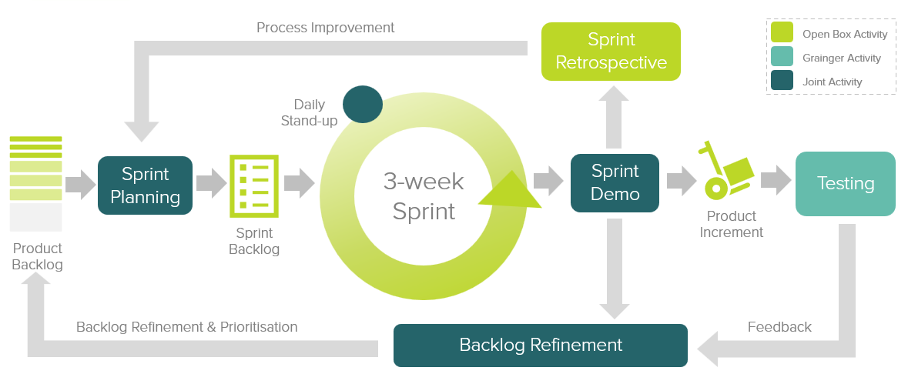
Figure 8: Agile Delivery Approach
Grainger representatives will be required to particulate in the following during each sprint cycle:
- Backlog Refinement – Open Box and Grainger representatives will meet to prioritise user stories on the backlog as well as review and agree on acceptance criteria for user stories at the top of the backlog.
- Sprint Planning – Outcomes on the backlog will be selected for the next sprint.
- Demo – Open Box will meet with Grainger representatives to demonstrate the outcomes delivered in the past 3-week period.
- Testing – Open Box will be responsible for unit testing and QA testing of functionality. Grainger representatives will conduct user acceptance testing of new functionality delivered in each sprint and provide feedback within 1 week of the demo.
- Stand Up – Regular, 15-minute stand up calls will be held to report on progress; the Grainger product owner is expected to participate regularly in these calls to provide feedback and give input on any questions that arise.
Feedback from demos and testing will be classified as either bugs or enhancements (depending on the user story and acceptance criteria). Bugs will be fixed in a subsequent sprint, whereas enhancements will be incorporated into the backlog and prioritized accordingly.
If it is expected that the critical functionality can no longer be delivered within the estimated cost and timeline, this will be communicated to Grainger who may choose to resolve this by adjusting the project scope and/or cost & timelines accordingly.

UAT
Designated Grainger business users will be given access to a UAT sandbox to test the functionality end-to-end and ensure that the overall solution is functioning as expected.
Issues raised will be classified as bugs or enhancements (as above). Bugs will be fixed during the UAT period. Any other enhancements or new requirements will be added to the backlog for future development.

Project Management
Open Box will deliver a progress report to Grainger on a regular basis, that will include:
- General status update
- Project risks
- Project milestones and timeline forecast based on the current scope of release 1.
Regular updates regarding any significant changes in scope or cost will be delivered to Grainger as and when they occur.

Availability
- Open Box resources will be contactable and available for meetings via conference calls/video conferences:
  - Monday to Friday 9am – 6pm South African time which corresponds to 7am – 4pm GMT, excluding public holidays.
- All work will be completed by Open Box offsite.

Acceptance
The parties hereto, each acting under due and proper authority, have executed this Agreement as of the day, month and year first written below.

For and on behalf of Open Box Software For and on behalf of Grainger plc

Signature: _____________________ Signature: _____________________
Name: _____________________ Name: _____________________
Position: _____________________ Position: _____________________
Date: _____________________ Date: _____________________

